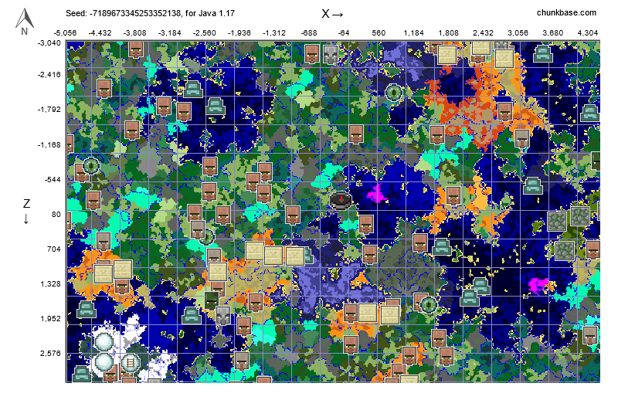The quick brown fox jumped over the lazy dog.

New page!

This page should be in landscape mode.